
Name: Abdul Samad
Program: BSSE Group A
Semester: 5th
Date: October 22, 2026
*-----------------------------------------------*

Lab Task 7
Task 1
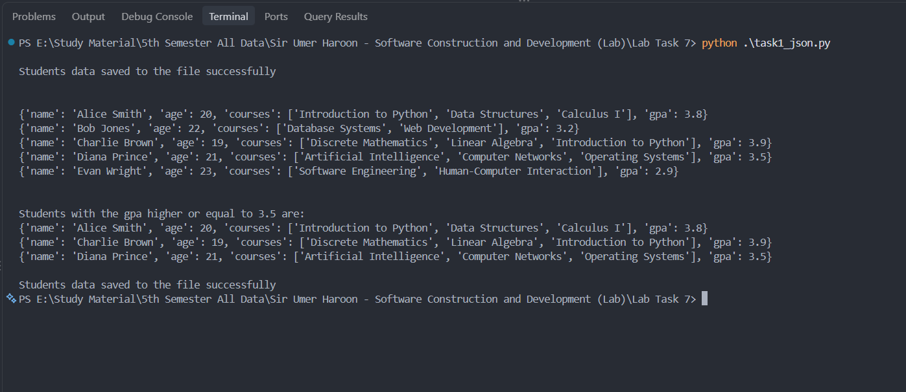
Reason for Indentation:

The indentation is used for prettiness of the code. In our example we use the indent=2 in our code so it means that our last curly or any bracket should be indented by 2 indents (which means it will be indented by 8 spaces) to make it more pretty so can make it indent=4 in this case our file will be looking very perfectly nice and more readable.

Task 2
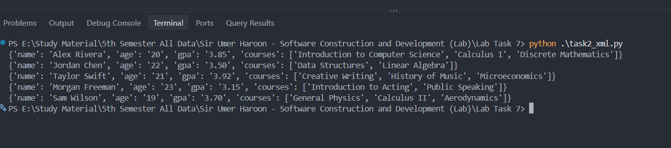

Comparison Between Json and XML from my code:

- The json file was easier to write by hand than xml file. As in json we can directly write everything while in xml we do write opening and closing tags for each thing so in hand writing json is easier. In short students.json was easier to write than students.xml.
- The xml file was larger in bytes and the reason for that in xml we store the opening and closing tags as well. So it occupy more space that json. Both students.json and top_students.json has less size than students.xml file.
- Json was easier to read for me than xml file.
- The xml file required more code to parse and read its content rather than the xml file.

Size comparison Of two files

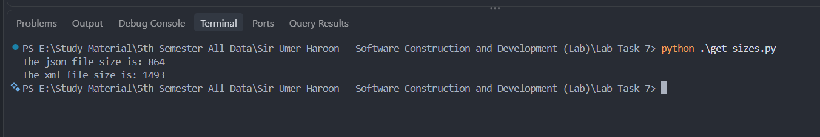

*-----------------------------------------------*

The End

